- Barchart
  - Erens Method

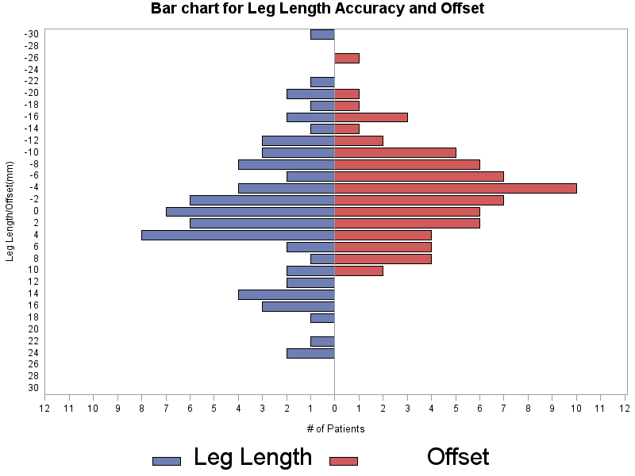
There are 90% measurements within -16.7 to 23.8(Leg Length), and -15.4 to 8.4 (Offset).

Quantile | Leg Length | Offset
100% Max | 30.7 | 18.8
99% | 30.7 | 18.8
95% | 23.8 | 8.4
90% | 16.3 | 6.8
75% Q3 | 9.6 | 4.4
50% Median | 1.0 | -0.6
25% Q1 | -6.2 | -7.4
10% | -11.2 | -11.6
5% | -16.7 | -15.4
1% | -30.7 | -19.0
0% Min | -30.7 | -19.0
  - Bradybury Method:

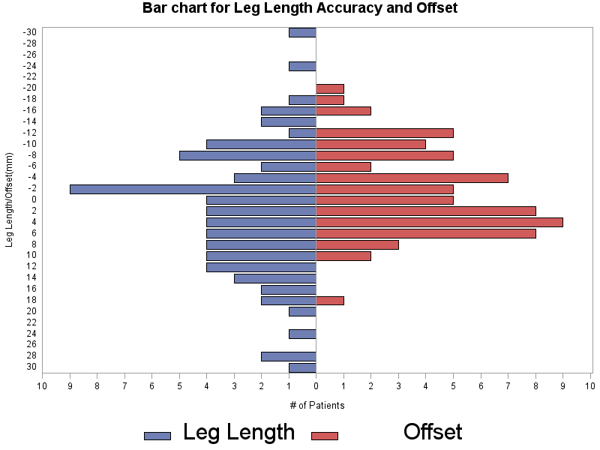

There are 90% measurements within -19.3 to 17.2(Leg Length), and -16.8 to 7.6 (Offset).
Quantile | Leg Length | Offset
100% Max | 24.8 | 9.4
99% | 24.8 | 9.4
95% | 17.2 | 7.6
90% | 15.9 | 6.1
75% Q3 | 5.6 | 1.4
50% Median | 0.0 | -3.3
25% Q1 | -8.0 | -7.2
10% | -15.9 | -12.9
5% | -19.3 | -16.8
1% | -29.1 | -26.8
0% Min | -29.1 | -26.8
- Mean and Standard Deviation:
Method | Variable | N | Mean | Std Dev | Std Error | Median | Minimum | Maximum | Lower Quartile | Upper Quartile
Erens
  lesser
  greater
  offset
  69
  71
  68
  1.9
  2.0
  -1.4
  8.8
  12.0
  7.5
  1.1
  1.4
  0.9
  1.8
  1.0
  -0.6
  -17.4
  -30.7
  -19.0
  21.2
  30.7
  18.8
  -4.2
  -6.2
  -7.4
  6.6
  9.6
  4.4
Bradybury
  lesser
  greater
  offset
  69
  69
  70
  0.5
  0.0
  -3.4
  8.5
  11.3
  7.3
  1.0
  1.4
  0.9
  -0.2
  0.0
  -3.3
  -21.0
  -29.1
  -26.8
  22.2
  24.8
  9.4
  -4.1
  -8.0
  -7.2
  6.2
  5.6
  1.4

- Mean Difference:
  - Leg Length(greater)
Method | N | Mean | 95% CL Mean |  | Std Dev | Std Err
Erens | 71 | 2.0 | -0.9 | 4.8 | 12.0 | 1.4
Bradybury | 69 | 0.03 | -2.7 | 2.7 | 11.3 | 1.4
Diff (Erens-Bradybury) |  | 1.9 | -2.0 | 5.8 | 11.6 | 2.0

  - Offset
Method | N | Mean | 95% CL Mean |  | Std Dev | Std Err
Erens | 68 | -1.4 | -3.2 | 0.4 | 7.5 | 0.9
Bradybury | 70 | -3.4 | -5.2 | -1.7 | 7.3 | 0.9
Diff (Erens-Bradybury) |  | 2.0 | -0.5 | 4.5 | 7.4 | 1.2

- Wilcoxon-Mann-Whitney test

P value=0.3871 to test leg length between two methods.
P value=0.1146 to test offset between two methods.

This is a nonparametric method without the assumption of normal distribution of the test variables.

For two sample t -test, the p values will be:
P value=0.3260 to test leg length between two methods.
P value=0.1135 to test offset between two methods.

